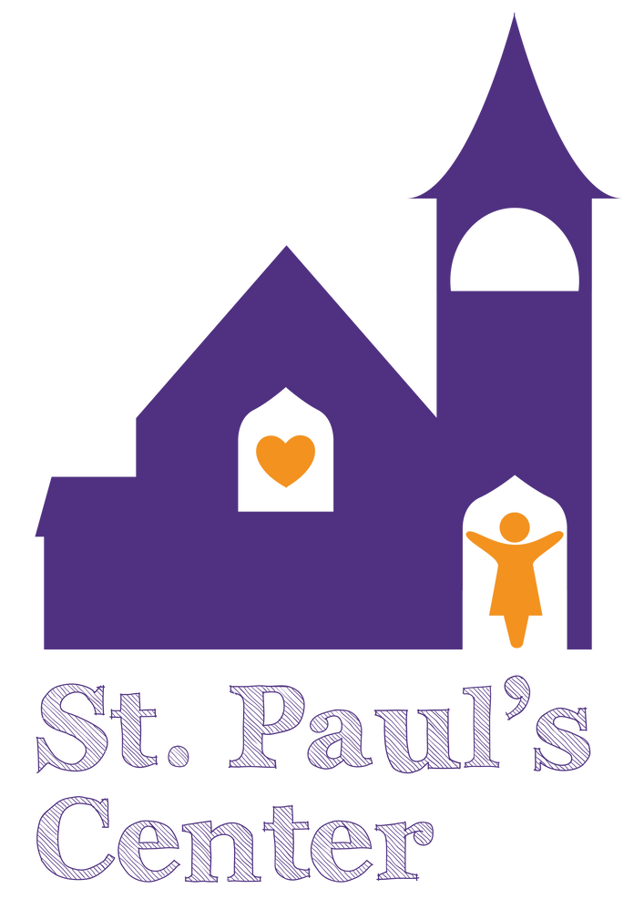
If You Would Like to Help This Year
Please complete the form on the reverse side or sign up on our website.
Mail by November 1, 2023, to:
PO Box 589
Rensselaer NY 12144 Attention: Housing Stability Advocate
St. Paul’s Center will match you with a family and contact you with more details about that family by November 19th.
If you have any questions about adopting a family please call Jason Chaplin, Housing Stability Advocate, at 518-434-2910.
If you are unable to adopt a family but would like to make a monetary donation, please make checks payable to:
St. Paul’s Center, Inc.
Thank you for helping to make this holiday season special for our families.
WHO WE ARE

St. Paul’s Center is a community that strives to awaken hope and rekindle dignity in families who seek comfort, support, and assistance in moving from homelessness to a sustainable future.

Check out our website to learn more about what we are accomplishing by providing services to homeless families in Rensselaer County and any upcoming events!

http://stpaulscenter.com/

Please contact us with any questions regarding holiday giving or for more information on St. Paul’s Center.

Jason Chaplin Housing Stability Advocate
PO Box 589
Rensselaer, NY 12144
Phone: 518-434-2910
2023 Holiday Season

Adopt-A-family!

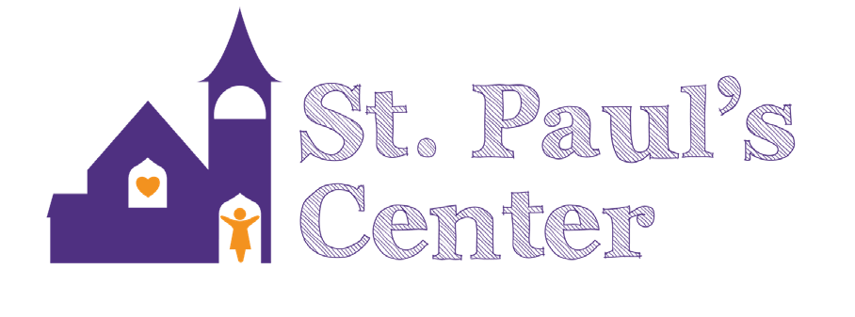
Help Us Make the 2023 Holiday Season a Joyful Time for All of the Families We Serve!
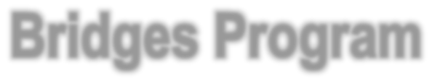
2023 Holiday Season
ADOPT-A-FAMILY

The St. Paul’s Center is a shelter for homeless mothers and their children and has served over 2,800 families since opening our doors in 2006. We quickly recognized a need to provide support to mothers and their children after they leave the shelter to prevent future incidents of homelessness. The B r i dges Program is staffed by our Housing Stability Advocate.
Adopting a St. Paul’s Center family for this holiday season means giving a mother the comfort of knowing her children will have a holiday to remember despite their hardships over the past year.
After you have decided to adopt a family, St. Paul’s Center will match your organization with a family of the size you have requested. A holiday wish list that the family has completed will be sent to
Organization
Name: Organization
Contact: Address:

Phone
number Fax:
E-mail:

you early in the season to allow plenty Yes, we/I would like to adopt a St. Paul’s Center

The Bridges Program works with the women for at least one year after moving into their own apartment or into a
of time to shop. The list will include clothing sizes and three items each family member would like. The total for
family. Please list the maximum number of family members you can adopt at this time:

transitional living program. The women
each family member will be No, our organization is unable to adopt a family

receive advocacy with the Department of Social Services, landlords, schools, and the legal system. They are also given assistance in finding continuing education programs or employment to help them move forward in their lives, along with finding proper daycare for their children. Knowing they can always turn to St. Paul’s Center for assistance gives the mothers confidence to succeed.
approximately $100; $25 for an outfit and three items at $25 each. You can bring the items wrapped and labeled to St. Paul’s Center, where they will be delivered for the holidays.

In 2022, over 60 families were adopted by generous individuals and organizations in the Capital District. With your help, we hope to maintain that number in 2023.
this year, but we would like to make a monetary donation in the amount of:
Thank you for all your support. Please return this form by November 1, 2023
St. Paul’s Center, Inc. Attn: Housing Stability Advocate PO Box 589 Rensselaer, NY 12144 Or Fax to 518-
689-2083
Attn: Housing Stability
Advocate

